**StarLabs 2022 - Documentation**

**PostgressSQL**

PostgreSQL is an object-relational database management system (ORDBMS) based on POSTGRES, PostgreSQL is an open-source descendant of this original Berkeley code. It supports a large part of the SQL standard and offers many modern features:

1. complex queries
2. foreign keys
3. triggers
4. updatable views
5. transactional integrity
6. multi version concurrency control

Also, PostgreSQL can be extended by the user in many ways, for example by adding new

1. data types
2. functions
3. operators
4. aggregate functions
5. index methods
6. procedural languages

***Why use Postgress?***

Postgres allows you to store large and sophisticated data safely. It helps developers to build the most complex applications, run administrative tasks and create integral environments. Biggest advantage is that it is open source.

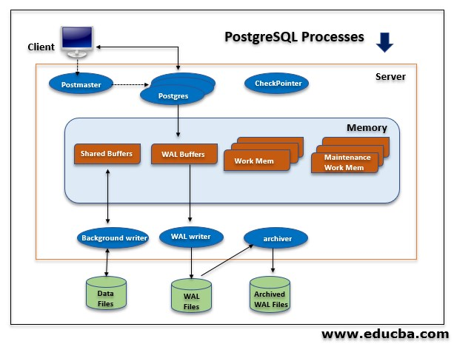***PostgressSQL vs MySQL***

**Key Differences:**

1. PostgreSQL is an Object Relational Database Management System (ORDBMS) whereas MySQL is a community driven DBMS system.
2. PostgreSQL support modern applications feature like JSON, XML etc. while MySQL only supports JSON.
3. Comparing PostgreSQL vs MySQL performance, PostgreSQL performs well when executing complex queries whereas MySQL performs well in OLAP & OLTP systems.
4. PostgreSQL is complete ACID compliant while MySQL is only ACID compliant when used with InnoDB and NDB.
5. PostgreSQL supports Materialized Views whereas MySQL doesn’t supports Materialized Views.

[*Click here to read more on PostgressSQL vs MySQL*](https://www.guru99.com/postgresql-vs-mysql-difference.html)